NAVDDX System

Back ground Information  Task: New Design and EMD Fabrication  System Used in: NAVDDX  Brief Description: Design and Manufacture the Navigation Distribution System for the Zumwalt Class of Destroyers.  Program: AN/SSN-6(V) – NAVSSI Block 4.3  DoD Customer: SSC Pacific  Results: Designed and built within budget and on time.  Part No: 43A-RB300 | 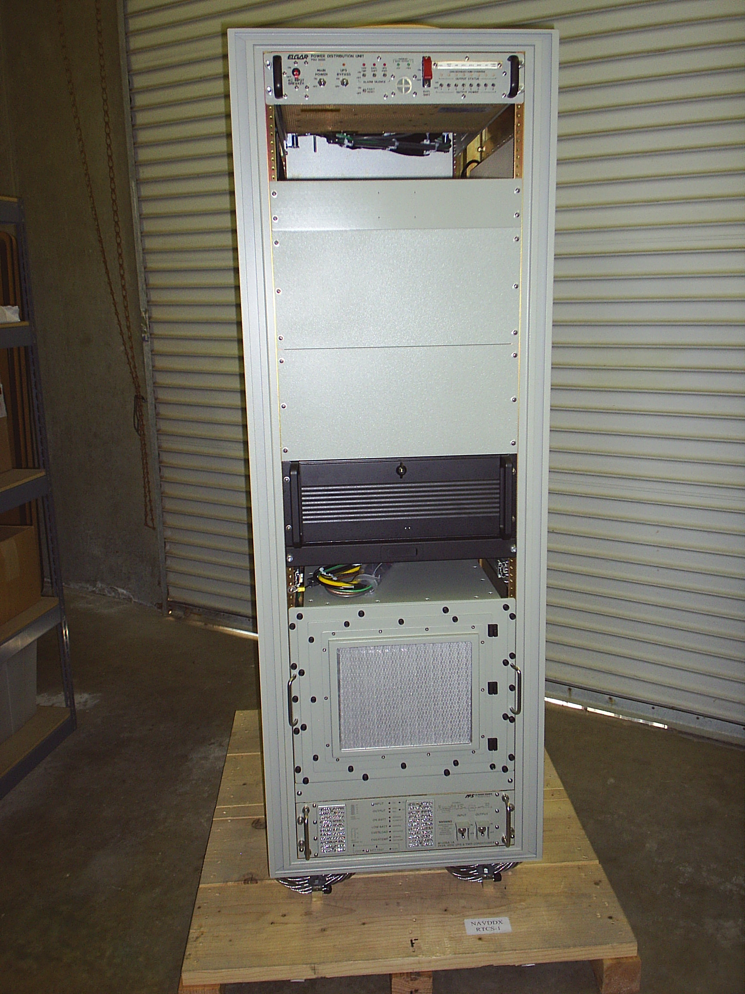  Front View
Specifications  - Military GPS and Fiber Optic Antenna Link  - Performs the Fusion and Distribution of:  - Precision Time and Frequency Data  - Navigation Data  - Ships Attitude Data  - Designed to:  - MIL-S-901D – Shock  - MIL-STD-167-1A Vibration  - MIL-STD-461F EMI/EMC  - Dual redundant system  - Includes:  - Power Distribution Unit  - Uninterruptible Power Supply  - VME Chassis w/Interface Card Set  - Maintainer Workstation | 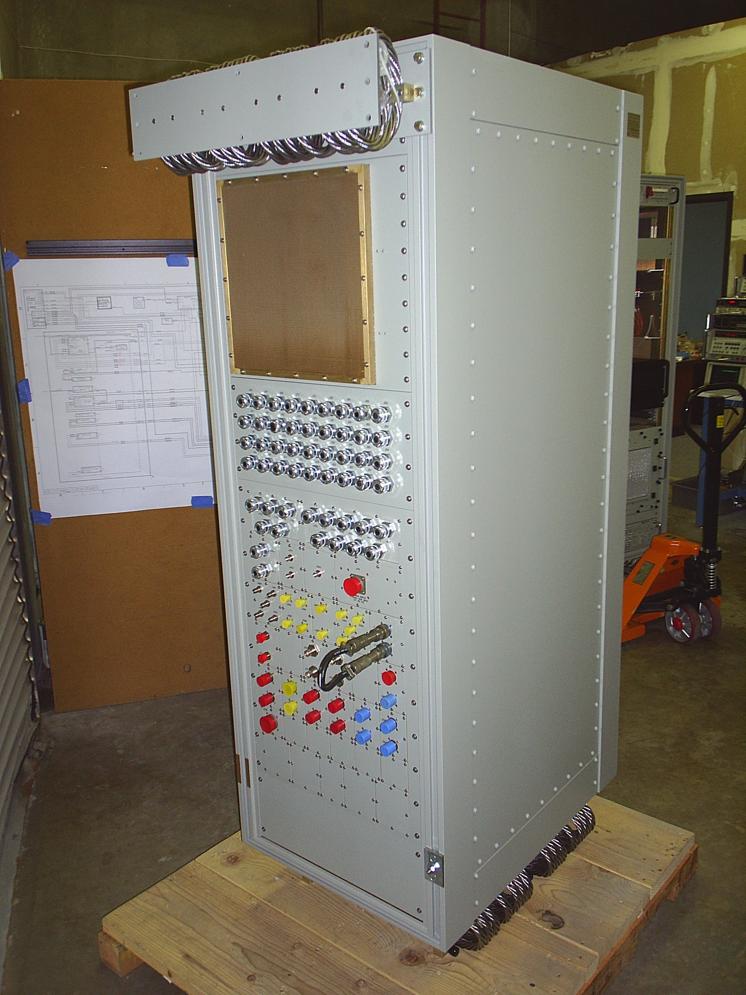  Back View

